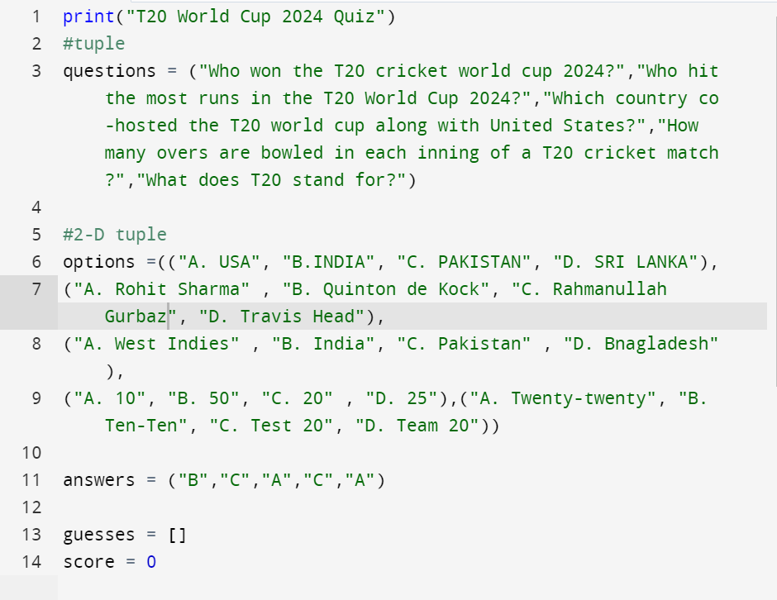

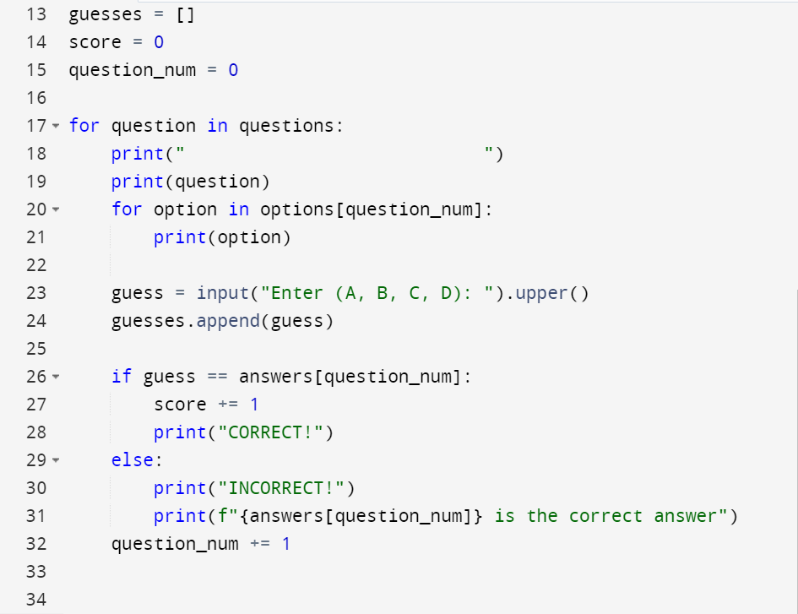

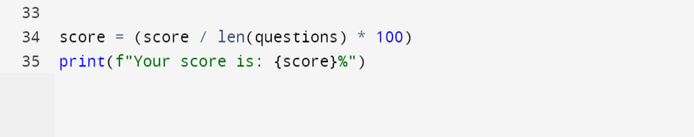

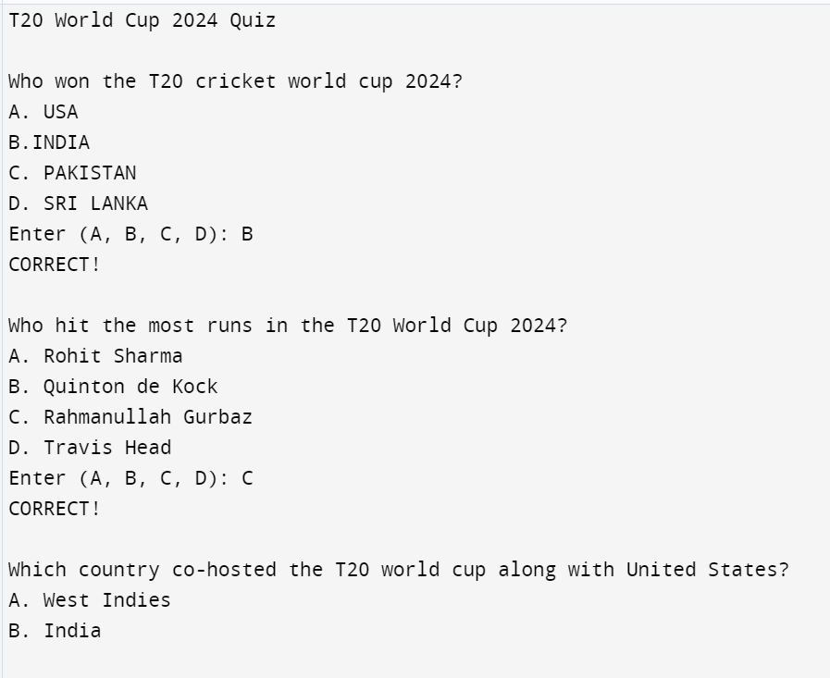

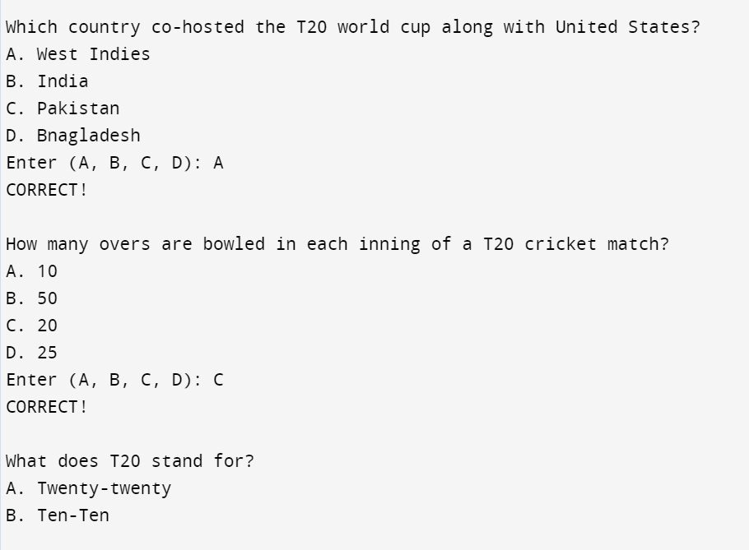

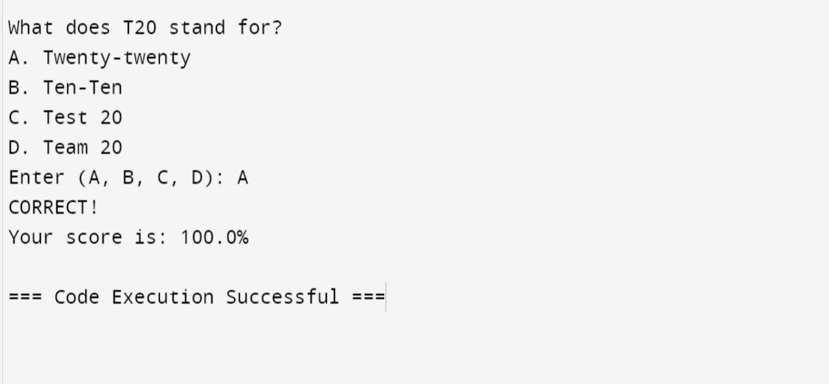

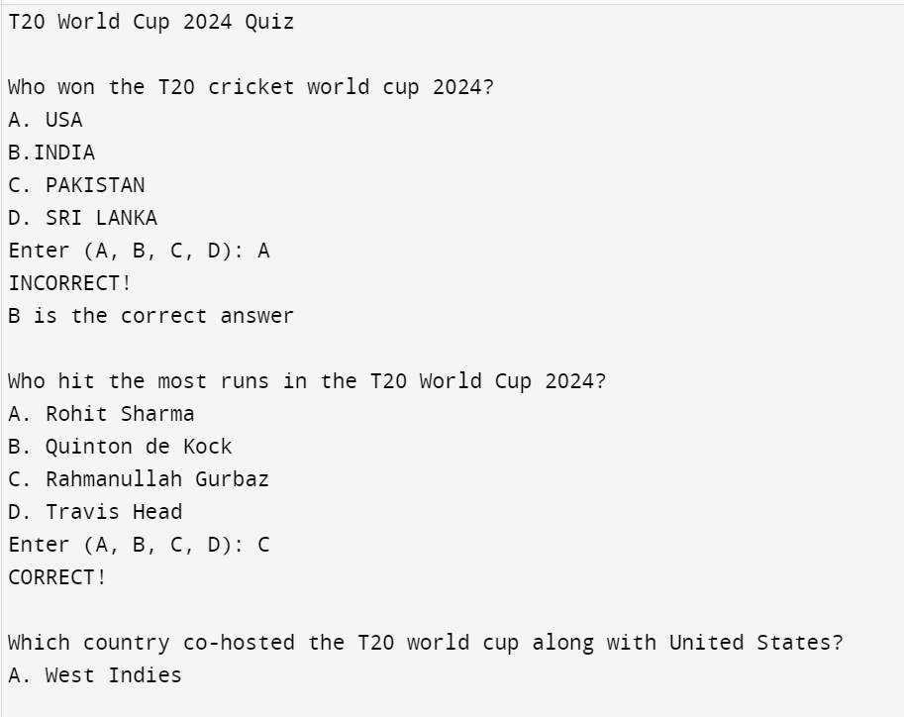

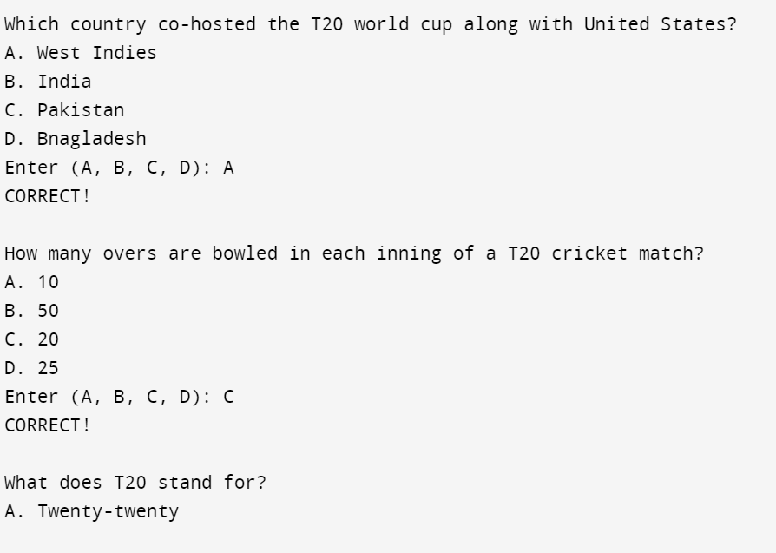

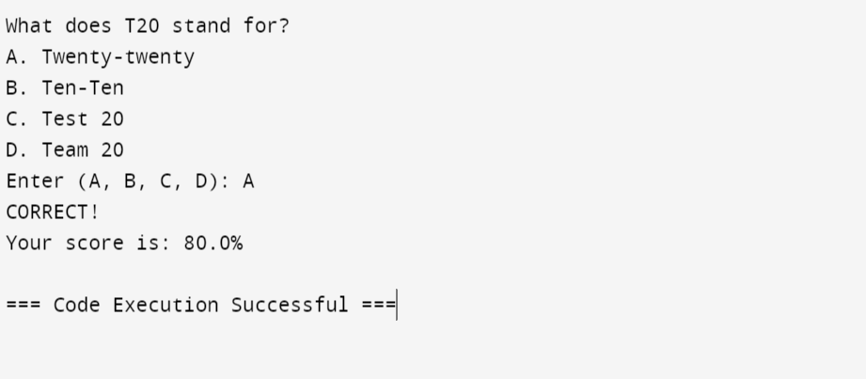

print("T20 World Cup 2024 Quiz")

#tuple

questions = ("Who won the T20 cricket world cup 2024?","Who hit the most runs in the T20 World Cup 2024?","Which country co-hosted the T20 world cup along with United States?","How many overs are bowled in each inning of a T20 cricket match?","What does T20 stand for?")

#2-D tuple

options =(("A. USA", "B.INDIA", "C. PAKISTAN", "D. SRI LANKA"),

("A. Rohit Sharma" , "B. Quinton de Kock", "C. Rahmanullah Gurbaz", "D. Travis Head"),

("A. West Indies" , "B. India", "C. Pakistan" , "D. Bnagladesh"),

("A. 10", "B. 50", "C. 20" , "D. 25"),("A. Twenty-twenty", "B. Ten-Ten", "C. Test 20", "D. Team 20"))

answers = ("B","C","A","C","A")

guesses = []

score = 0

question_num = 0

for question in questions:

print(" ")

print(question)

for option in options[question_num]:

print(option)

guess = input("Enter (A, B, C, D): ").upper()

guesses.append(guess)

if guess == answers[question_num]:

score += 1

print("CORRECT!")

else:

print("INCORRECT!")

print(f"{answers[question_num]} is the correct answer")

question_num += 1

score = (score / len(questions) * 100)

print(f"Your score is: {score}%")